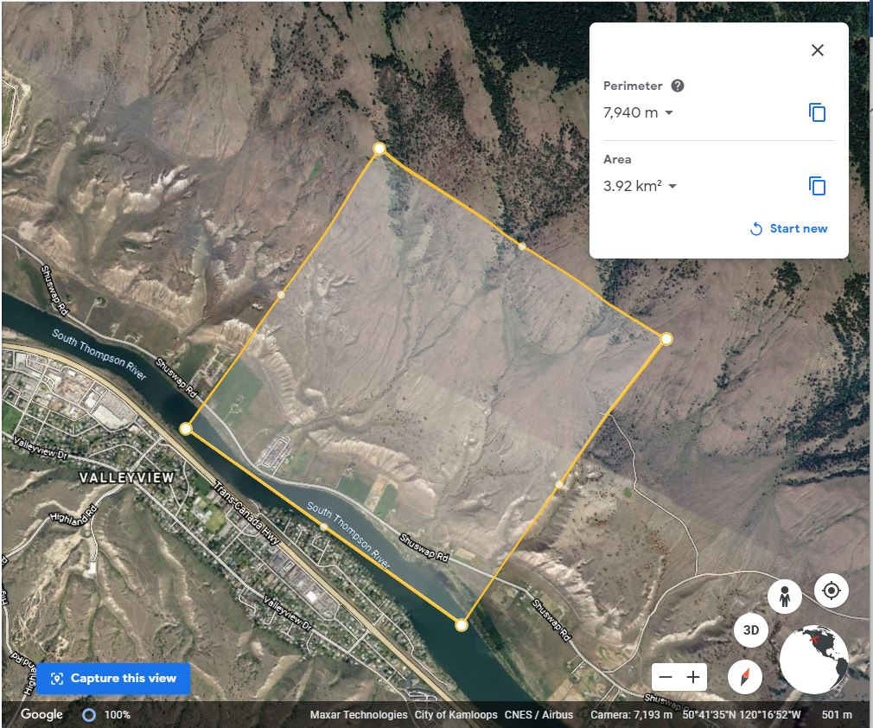

Figure 1. Figure 1 caption goes here

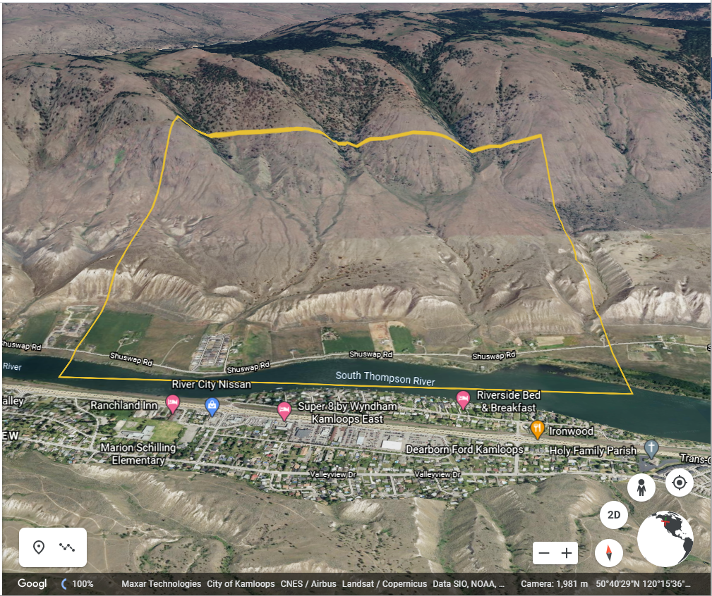

Figure 2. figure 2 caption goes here
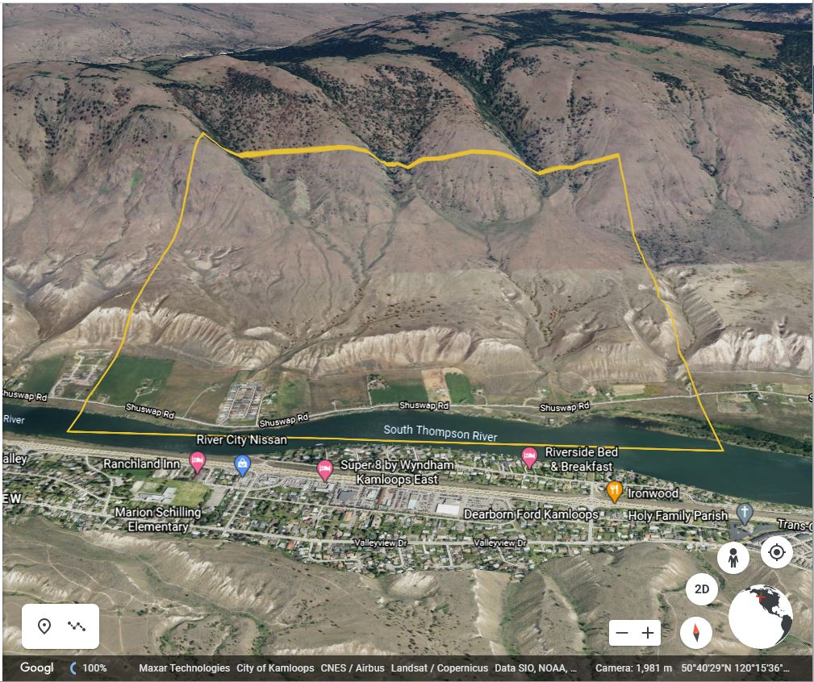
Figure 3. Components and processes impacting the reservoirs and transfers of water within the hydrosphere.
[Grab your reader’s attention with a great quote from the document or use this space to emphasize a key point. To place this text box anywhere on the page, just drag it.]
Figure 3. Components and processes impacting the reservoirs and transfers of water within the hydrosphere.
[Grab your reader’s attention with a great quote from the document or use this space to emphasize a key point. To place this text box anywhere on the page, just drag it.]
[Grab your reader’s attention with a great quote from the document or use this space to emphasize a key point. To place this text box anywhere on the page, just drag it.]
[Grab your reader’s attention with a great quote from the document or use this space to emphasize a key point. To place this text box anywhere on the page, just drag it.]

